- Affiliation Author #1
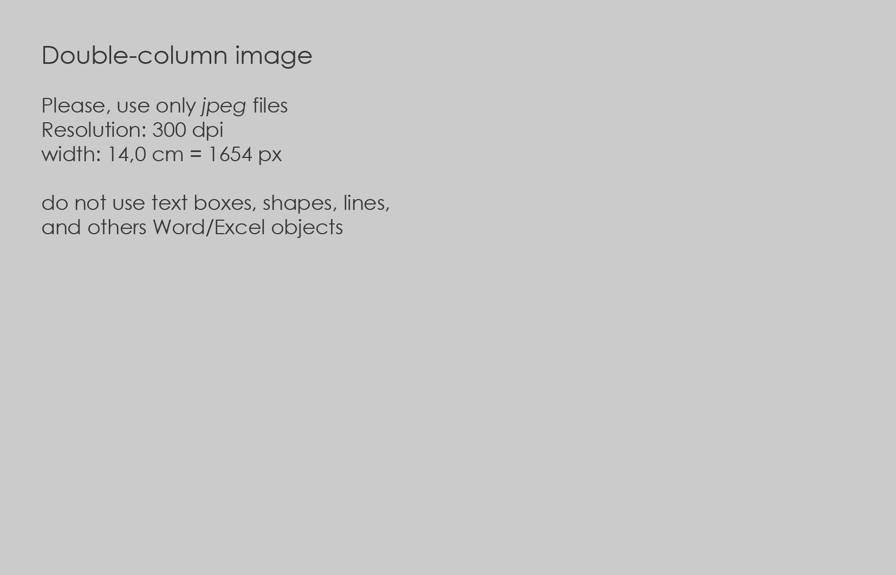
Fig.1 – Example of fugure and caption (a two-column figure is 14 cm large)¹
- Affiliation Author #2
- Affiliation Author #3

Introduction
Type your abstract here: please, use 8000 ± 200 characters, including spaces. Don’t change font size or spacing, and use italics for emphasis: do not underline! This document is a template for Microsoft Word versions 6.0 or later, you can use it to prepare your manuscript for book of abstract
Author 1^{I}
Author 2 ^{II}
Author 3 ^{III}
…

PAPER TITLE (MAX 80 CHAR.)
Subtitle (optional, max 40 char.)
Do not change the font sizes or line spacing to squeeze more text into a limited number of pages. Use italics for emphasis; do not underline. To insert images in Word, position the cursor at the insertion point and either use Insert | Picture | From File or copy the image to the Windows clipboard and then Edit | Paste Special | Picture (with “float over text” unchecked). The Editorial Committee will do the final formatting of your paper.

Font type and size
For paragraph titles use Cambria, size 9 bold, or select “Title 1” style. For subparagraph titles use Cambria, size 9 bold italic, or select “Title 1” style and apply italic mode. Use numbred paragraphs (and numbred subparagraphs) only if you really need it. For body text use Cambria, size 9, regular, or select “Normal” style.
For references and notes usa Cambria, size 8, regular, or select “Normal” style and resize font height to 8.

Mother-tongue version
For paragraph titles use Cambria, size 8 bold and italic, or select “Title 2” style. For body text use Cambria, size 8, italic, or select “Normal” style, and resize font height to 8 and select “Italic”. For references and notes usa Cambria, size 7, italic, or select “Normal” style, and resize font heigt to 7 and select “Italic”.

Paper Limits
The paper, including english and mother-tomgue version, with images inserted should not exceed 2 pages. (For any additional page, see Call to know the extra cost).

Figures
Format and save your graphic images using a suitable graphics processing program that will allow you to create the images as PostScript (PS), Encapsulated PostScript (EPS), Tagged Image File Format (TIFF), or JPG sizes them, and adjusts the resolution settings.
Figures and graphics should be prepared in RGB with 300 dpi resolution and saved with no compression, 8 bits per pixel.
Name pictures as Fig.1, Fig.2, tables as Tab.1, Tab.2, etc. For captions, use Century Gotic font, size 8, or use “Caption” style. Use Notes at the end of the capiton if you need to indicate the figure source. Do not exceed 120 characters including spaces: add extra explanations in the footnote or in the text of the article.

Sizing of Graphics
Pictures, tables and graphics could be be are one, two or three column wide, as you can see in the examples in this template. We recommend that you avoid sizing figures less than one column wide, as extreme enlargements may distort your images and result in poor reproduction. Therefore, it is better if the image is slightly larger, as a minor reduction in size should not have an adverse affect the quality of the image.
Place figure captions below the figures. If your figure has two parts, include the labels “(a)” and “(b)” as part of the artwork. Please verify that the figures and tables you mention in the text actually exist. Do not use text boxes, shapes, lines, and others Word/Excel objects overlapped on the figures.
Tables
Create your tables with Insert / Tables command. Please, do not convert tables into pictures in order to reduce the amount of characters of your paper. Choose a single, double or triple-column table (6.5, 14.0 or 22.0 cm large) according to the amount of data you need to enter. For captions, use Century Gotic font, size 8, or use “Caption” style. Use Notes at the end of the capiton if you need to indicate the figure source. Do not exceed 120 characters including spaces: add extra explanations in the footnote or in the text of the article.

Abbreviations and Acronyms
Define abbreviations and acronyms the first time they are used in the text, even after they have already been defined in the abstract. Abbreviations such as IEEE, SI, ac, and dc do not have to be defined.

Column 1 | Column 2 | … | Column n+1
Row 1 | Item 1,1 | … | Item 1,n
Row 2 | Item 2,1 | … | Item 2,n
… | … | … | …
Row k | Item k,1 | … | Item k,n
Tab.1 – Exemple of a signle-column table (6.5 cm large).
Abbreviations that incorporate periods should not have spaces: write “C.N.R.S.,” not “C. N. R. S.” Do not use abbreviations in the title unless they are unavoidable.
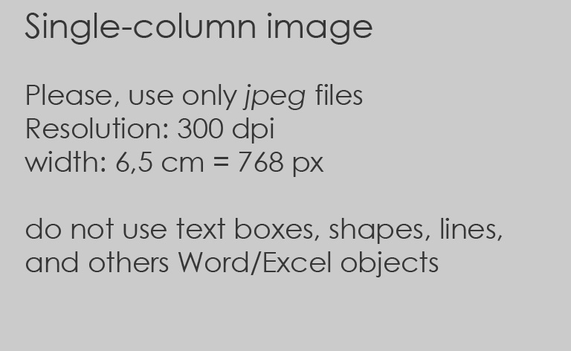
Fig.2 – Example of fugure and caption (a single-column figure is 6.5 cm large)²

Equations
Number equations consecutively with equation numbers in parentheses flush with the right margin, as in (1). First use the equation editor to create the equation. Then select the “Equation” markup style. Press the tab key and write the equation number in parentheses. To make your equations more compact, you may use the solidus ( / ), the exp function, or appropriate exponents. Use parentheses to avoid ambiguities in denominators. Be sure that the symbols in your equation have been defined before the equation appears or immediately following. Italicize symbols (T might refer to temperature, but T is the unit tesla). Refer to “(1),” not “Eq. (1)” or “equation (1),” except at the beginning of a sentence: “Equation (1) is ... .”

$e^{iπ}+1=0$ (1)

Lists
Please, use the marker “-“ to create a list of items. For example: before submitting the article, please check this list:
- Item n.1
- Item n.2
- …
If you need a numbered list, use the style shown below:
- Item n.1
- Item n.2

References and final check list
References
Number citations consecutively in square brackets. The sentence punctuation follows the brackets. Multiple references are each numbered with separate brackets. When citing a section in a book, please give the relevant page numbers. In sentences, refer simply to the reference number. Do not use “Ref. [3]” or “reference [3]” except at the beginning of a sentence: “Reference [3] shows ... .” Please note that the references at the end of this document are in the preferred referencing style. Give all authors’ names; do not use “et al.” unless there are six authors or more. Use a space after authors’ initials. Papers that have not been published should be cited as “unpublished”. Papers that have been accepted for publication, but not yet specified for an issue should be cited as “to be published”. Papers that have been submitted for publication should be cited as “submitted for publication”. Please give affiliations and addresses for private communications. Capitalize only the first word in a paper title, except for proper nouns and element symbols. For papers published in translation journals, please give the English citation first, followed by the original foreign-language citation. For Reference rules, see the following examples:
- Books with one author [1];
- Books with two-six authors [2];
- Books with six or more authors [3];
- Books with no author [4]
- Books with different editions [5];
- Electronic book [6];
- Dictionary or Encyclopedia with known author [7];
- Dictionary or Encyclopedia without author [8];
- Chapter in an edited book [9][10];
- Journal [11] and newspaper/magazine article [15] with author;
- Newspaper article without author [16]
- Electronic article with [12] and without [13] DOI number;
- Conference paper [14];
- Govenrment report [17];
- Web page with author [18];
- Web page without author [19];
- Web page without date [20];
- Web page with corporate author [21];
- Web Encyclopedia with author [22];
- Web Encyclopedia without author [23];
- Web open source editable Encyclopedia [24].
Don’t repeat References in mother-tongue vesion.

Final check list
Before submitting the article, please verify this list:
- Check grammar and syntax;
- Remove double spaces between words;
- Remove spaces before commas;
- Turn off the “Review” command in Microsoft Words
- Do not repeat REFERENCES paragraph in Mothertongue version
- Please do not use automatic endnotes in Word, rather, type the reference list like this:

Keywords: English keyword 1, En. keyword 2, En. keyword 3, En. keyword 4, En. keyword 5

ACKNOWLEDGMENT (optional)
Type here your (optional) aknowledgment

REFERENCES
- Berkman, R. I. (1994). Find it fast: How to uncover expert information. New York: Harper Perrenial.
- Moir, A., & Jessel, D. (1991). Brain sex: the real difference between men and women. London: Mandarin.
- Johnson, L., Lewis, K., Peters, M., Harris, Y., Moreton, G., Morgan, B. et al. (2005). How far Is far? London: McMillan.
- The CCH Macquarie dictionary of business. (1993). North Ryde, NSW: CCH Australia.
- DeHart, G. B., Alan Sroufe, L., & Cooper, R. G. (1995). Child development: Its nature and course (4th ed.). Boston: McGraw-Hill.
- Pettinger, R. (2002). Global organizations. Oxford: Capston Publishing. Available from NetLibrary database.
- Wolman, B.B. (1989). Dictionary of behavioral science (2nd ed.). San Diego: Academic Press.
- Treccani Enciclopedia italiana di Scienze ed Arti. (1938). Roma: Istituto dell’enciclopedia italiana.
- Baker, F. M., & Lightfoot, O. B. (1993). Psychiatric care of ethnic elders. In A. C. Gaw (Ed.), Culture, ethnicity, and mental illness (pp. 517-552). Washington DC: American Psychiatric Press.
- Scott, D. (2005). Colonial governmentality. In J. X. Inda (Ed.) Anthropologies of modernity (pp.21-49). Retrieved from Wiley InterScience database.
- Schafer, J.L. & Kang, J. (2008). Average causal effects from nonrandomized studies: A practical guide and simulated example. Psychological Methods, 13, 279- 313.
- Fletcher, David & Wagstaff, Christopher R. D. (2009). Organizational psychology in elite sport: Its emergence, application and future. Psychology of Sport and Exercise, 10(4), 427-434. doi:10.1016/j.psychsport.2009.03.009
- Shu-Cheng, Steve, Chi - Friedman, Raymond A. & Yang, Mei-Yu. (2009). Are supervisors fair mediators? The effects of personality traits and age difference on expected mediation fairness. Social Behavior and Personality, 37(1), 59-118. Retrieved from http://www.swetswise.com/ titleBank/ getAtoZList.do?title=187408
- Bohrer, S., Zielke, T., & Freiburg, V. (1995). Integrated obstacle detection framework for intelligent cruise control on motorways. Paper presented at IEEE Intelligent Vehicles Symposium. Detroit, MI: Piscataway.
- Cook, D. (2002, January 28). All in the mind. The Age, p. 8.
- Meeting the needs of counsellors. (2001, May 5). The Courier Mail, p. 22.
- Queensland Health. (2005). Health Systems Review Final Report. Brisbane: Queensland Government.
- Atherton, J. (2005). Behaviour Modification. Retrieved February 5, 2009, from http://www.learningandteaching.info/learnin g/ behaviour_mod.htm
- Behaviour modification. (2007). Retrieved February 5, 2009, from http://www.educational- psychologist.org.uk/behaviour.html
- Society of Clinical Psychology. (n.d.) About Clinical Psychology. Retrieved January 28, 2009, from http://www.apa.org/divisions/div12/ aboutcp.html
- Queensland Health. (2008). Healthy start in life. Retrieved March 10, 2009, from http://www.health.qld.gov.au/ph/documents/ saphs/hsil_full_doc.pdf.
- Grayson, C. (1971). Bonincontri, Lorenzo. Dizionario Biografico degli Italiani, 12. Retrieved from https://www.treccani.it/enciclopedia /lorenzo-bonincontri_(Dizionario-Biografico)
- Legno. (2012). Enciclopedia online Treccani. Retrieved from https://www.treccani.it/enciclopedia/legno/
- Legno. (2020). Wikipedia. Retrieved November 16, 2020, from https://it.wikipedia.org/ wiki/Legno

NOTES
- The image source is: www.wikipedia.en
- Image of the Author
- Nunc euismod a mauris a fringilla. Sed sed eleifend nunc. Ut nibh risus, rhoncus quis venenatis tincidunt, tristique gravida orci. Donec a risus blandit, laoreet nibh ut, pellentesque libero.

